Project Work (Part-2)- Set Up a Live WordPress Instance on Ubuntu EC2

Objective

By the end of this exercise, you will have a live WordPress website running on an Ubuntu EC2 instance using the LAMP stack (Linux, Apache, MySQL, PHP).

Estimated Time

60–75 Minutes

Prerequisites
- AWS Account
- EC2 permissions
- Ubuntu 22.04 LTS EC2 instance
- Security Group allowing:
  - SSH (22)
  - HTTP (80)
- Key Pair for SSH access

Architecture

Internet

|

Public IP Address

|

Ubuntu EC2 Instance

|

+-------------+-------------+

| |

Apache Web Server MySQL Server

| |

+-------------+-------------+

|

WordPress

Part 3 – Update Ubuntu

Update all installed packages.

sudo apt update

Part 4 – Install Apache Web Server

Install Apache.

sudo apt install apache2 -y

Start Apache.

sudo systemctl start apache2

Enable Apache at boot.

sudo systemctl enable apache2

Check Apache status.

sudo systemctl status apache2

Verify Apache

Open

http://<Public-IP>

Expected Output

Apache2 Ubuntu Default Page

Part 5 – Install MySQL Server

Install MySQL.

sudo apt install mysql-server -y

Start MySQL.

sudo systemctl start mysql

Enable MySQL.

sudo systemctl enable mysql

Verify.

sudo systemctl status mysql

Part 6 – Secure MySQL

Run

sudo mysql_secure_installation

Choose:
- Validate Password → No
- Remove anonymous users → Yes
- Disallow remote root login → Yes
- Remove test database → Yes
- Reload privilege tables → Yes

Part 7 – Create the WordPress Database

Login to MySQL.

sudo mysql

Execute:

CREATE DATABASE wordpress;

CREATE USER 'wpuser'@'localhost' IDENTIFIED BY 'wppassword';

GRANT ALL PRIVILEGES ON wordpress.* TO 'wpuser'@'localhost';

FLUSH PRIVILEGES;

EXIT;

Part 8 – Install PHP

Install PHP and required modules.

sudo apt install -y \

php \

libapache2-mod-php \

php-mysql \

php-cli \

php-curl \

php-gd \

php-xml \

php-mbstring \

php-zip

Restart Apache.

sudo systemctl restart apache2

Check PHP version.

php -v

Part 9 – Download WordPress

Move to the temporary directory.

cd /tmp

Download WordPress.

wget https://wordpress.org/latest.tar.gz

Extract it.

tar -xvzf latest.tar.gz

Copy WordPress files.

sudo cp -r wordpress/* /var/www/html/

Part 10 – Configure File Permissions

Set ownership.

sudo chown -R www-data:www-data /var/www/html/

Set permissions.

sudo chmod -R 755 /var/www/html/

Part 11 – Configure WordPress

Move to the web directory.

cd /var/www/html

Create the configuration file.

sudo cp wp-config-sample.php wp-config.php

Edit the configuration.

sudo nano wp-config.php

Update the following values.

define('DB_NAME', 'wordpress');

define('DB_USER', 'wpuser');

define('DB_PASSWORD', 'wppassword');

define('DB_HOST', 'localhost');

Save the file.

Part 12 – Restart Apache

sudo rm /var/www/html/index.html

sudo systemctl restart apache2

Part 14 – Complete the WordPress Installation

Open a browser.

http://<Public-IP>

The WordPress installation page appears.

Provide:
Field | Example
Site Title | My WordPress Blog
Username | admin
Password | Password@123
Email | admin@example.com

Click

Install WordPress

Part 15 – Login to WordPress

Open

http://<Public-IP>/wp-admin

Login using the administrator credentials.

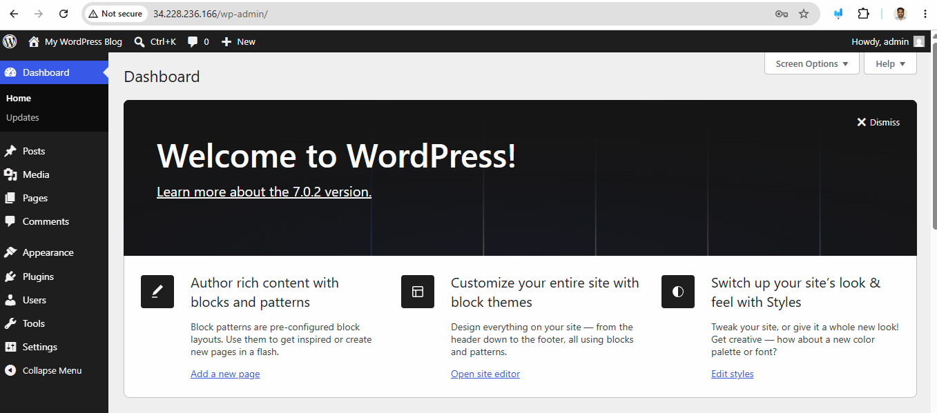

Part 16 – Publish Your First Blog

Navigate to

Posts → Add New

Create a post.

Example

Title:

Welcome to My Blog

Content:

This is my first WordPress blog hosted on AWS EC2 Ubuntu.

Click

Publish

Part 17 – View the Website

Open

http://<Public-IP>

Expected Output

Your WordPress homepage displays the published blog post.

